Assignment 1

* **Create VPC with 2 subnets and launch 2 instances to check the communication between two Instances.**

VPC

Navigate to VPC

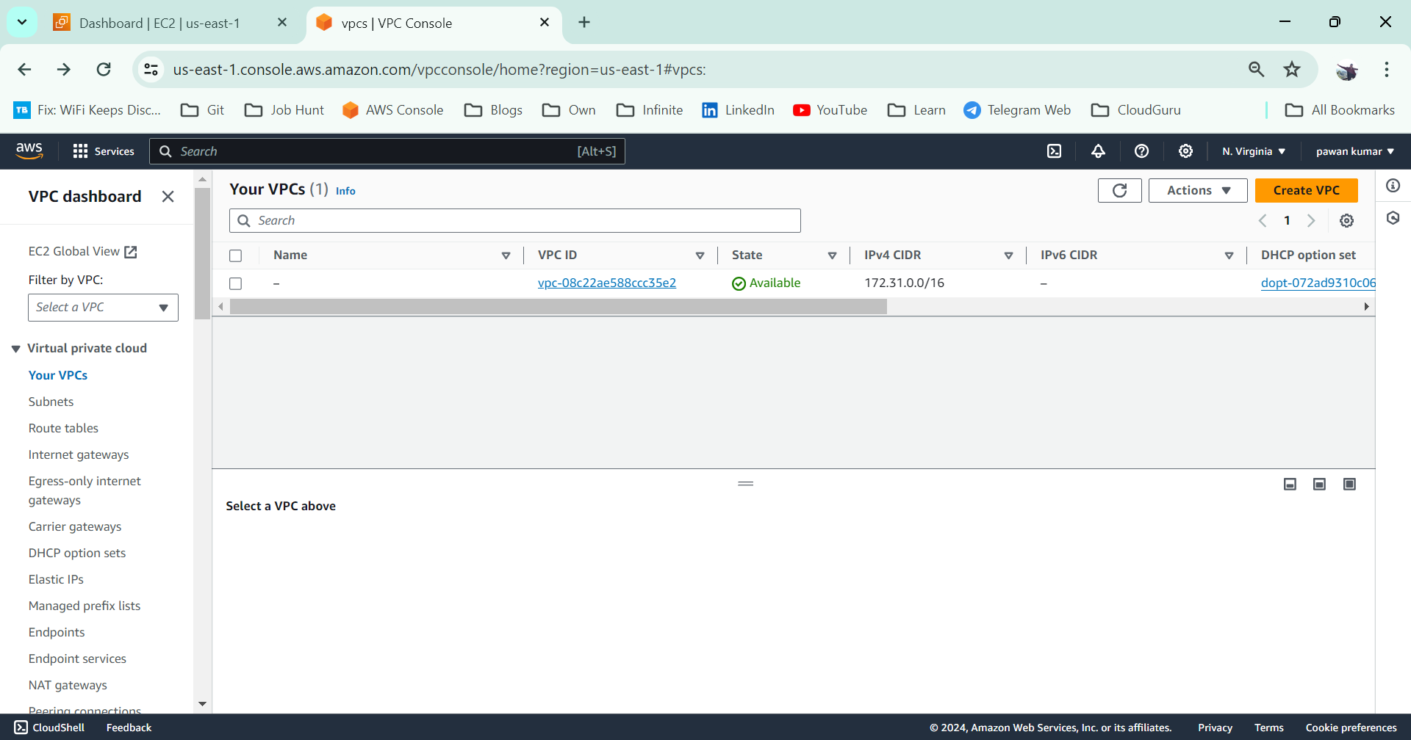

VPC creation

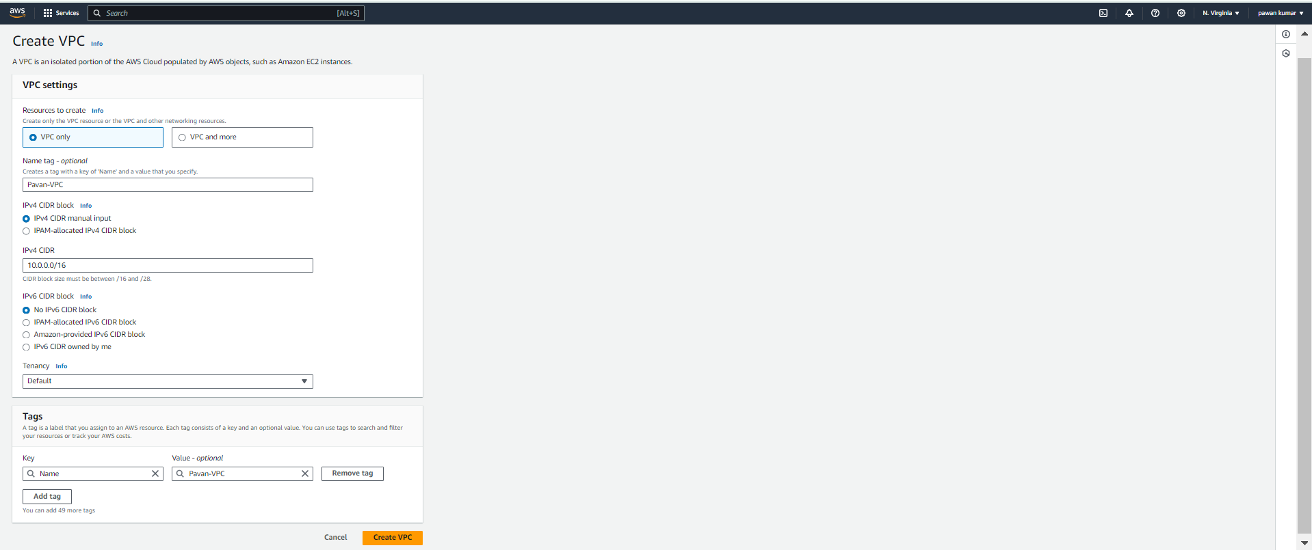

VPC got created

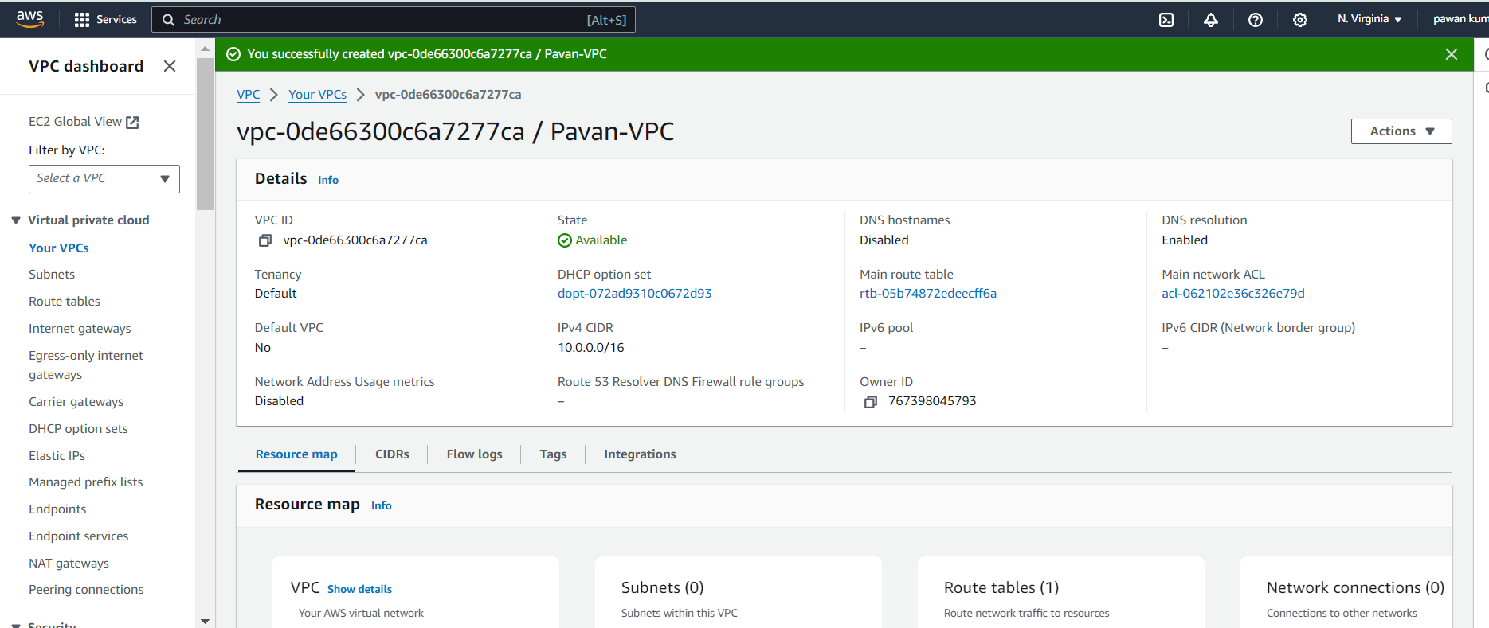

**Navigate to subnets & then click on Create Subnets**

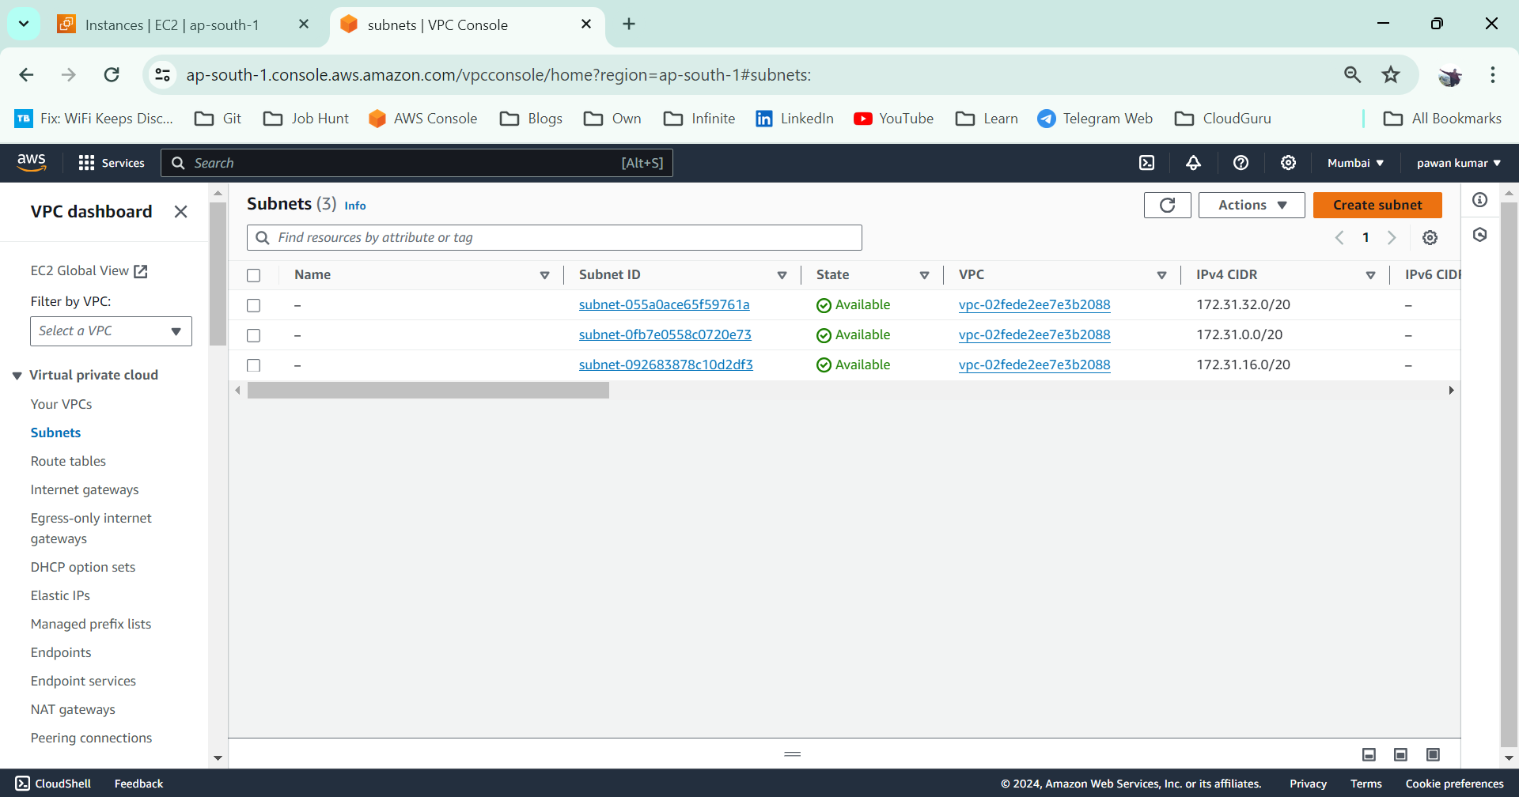

**Create Subnet within our custom VPC**

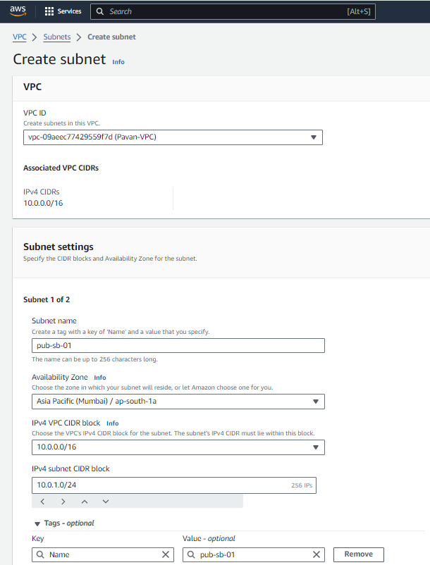

**Sb-02**

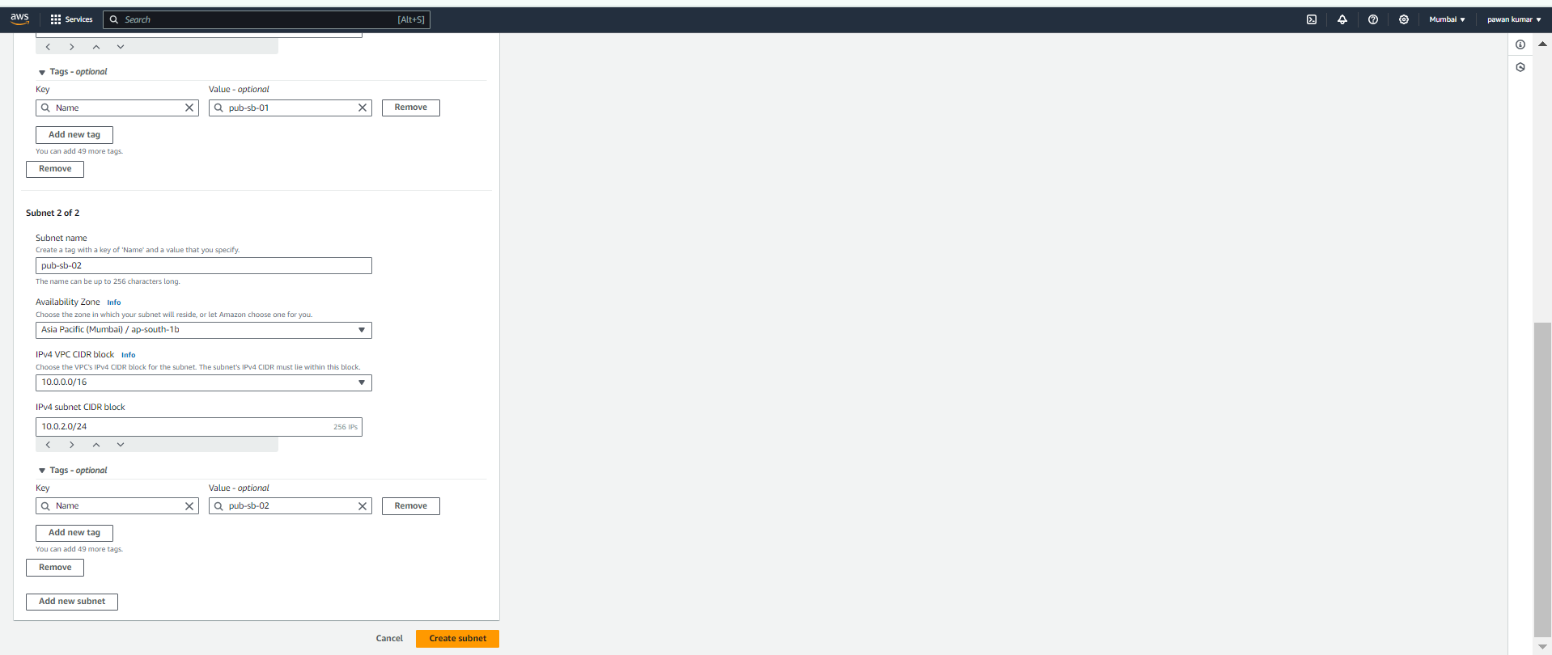

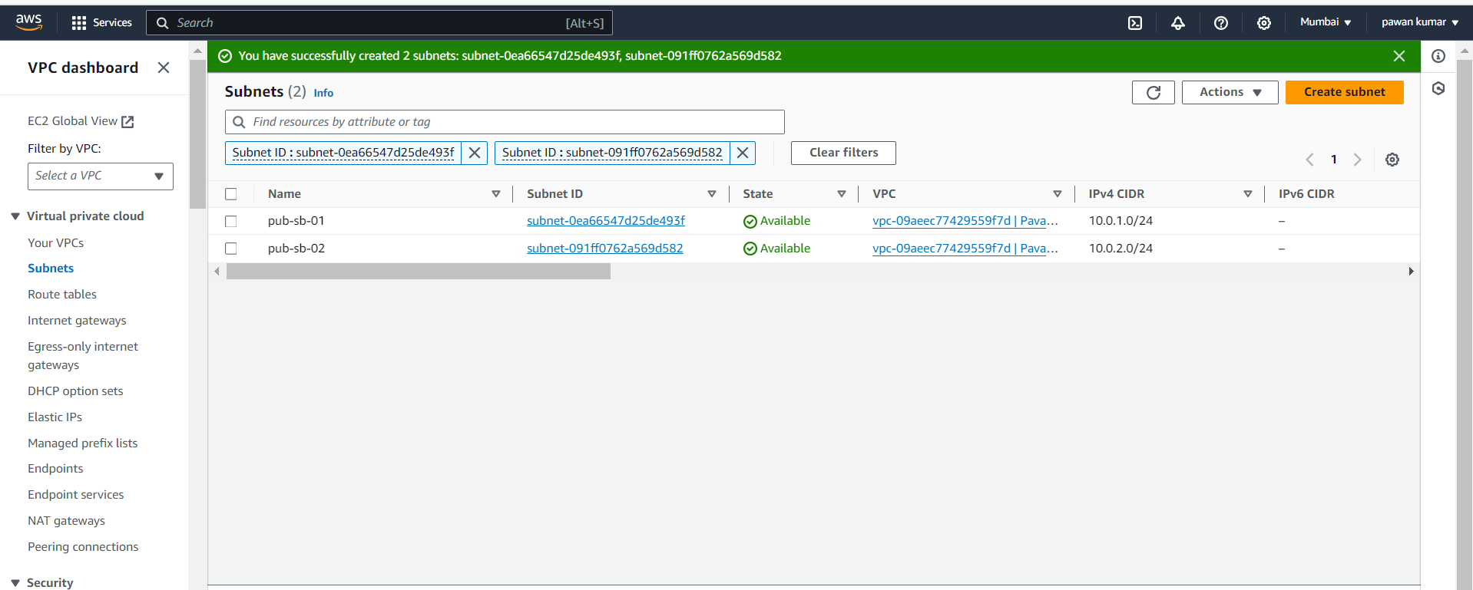

**Select Sb 🡪 Actions 🡪 Edit sb settings**

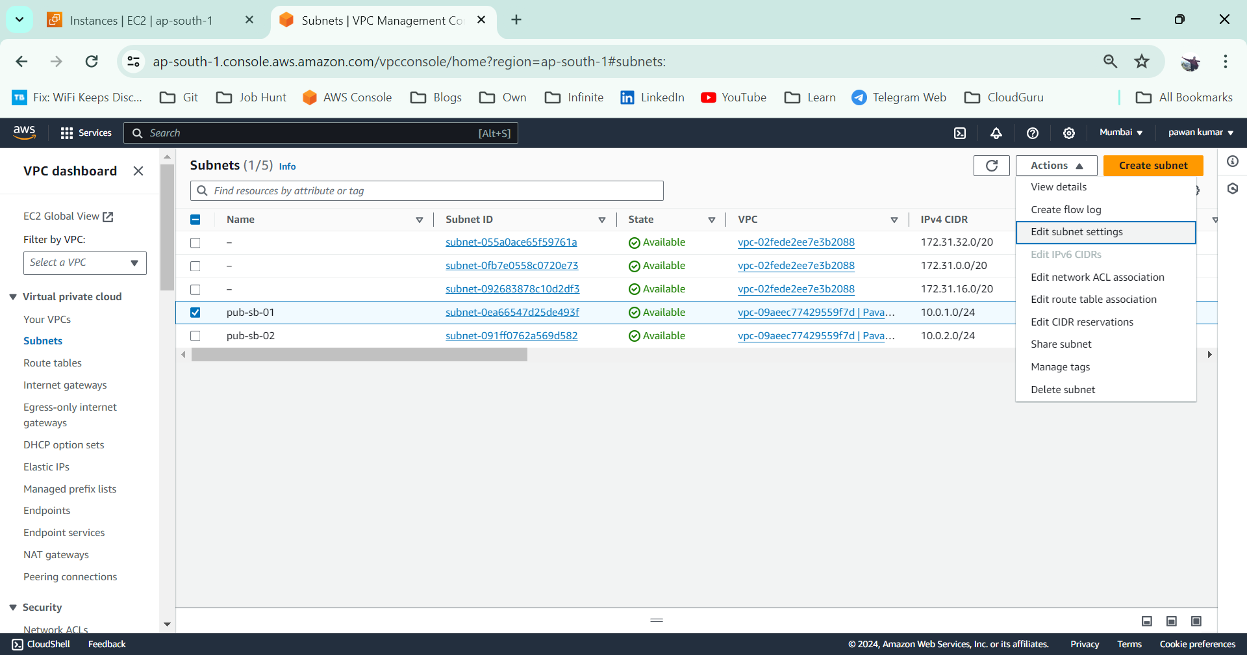

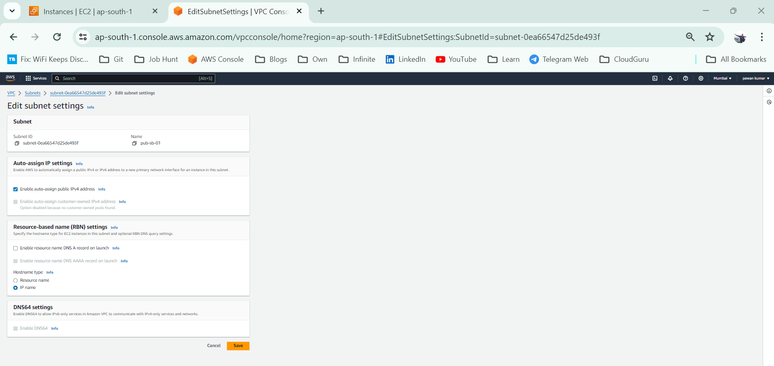

**Repeat same step for sb-02 as well**

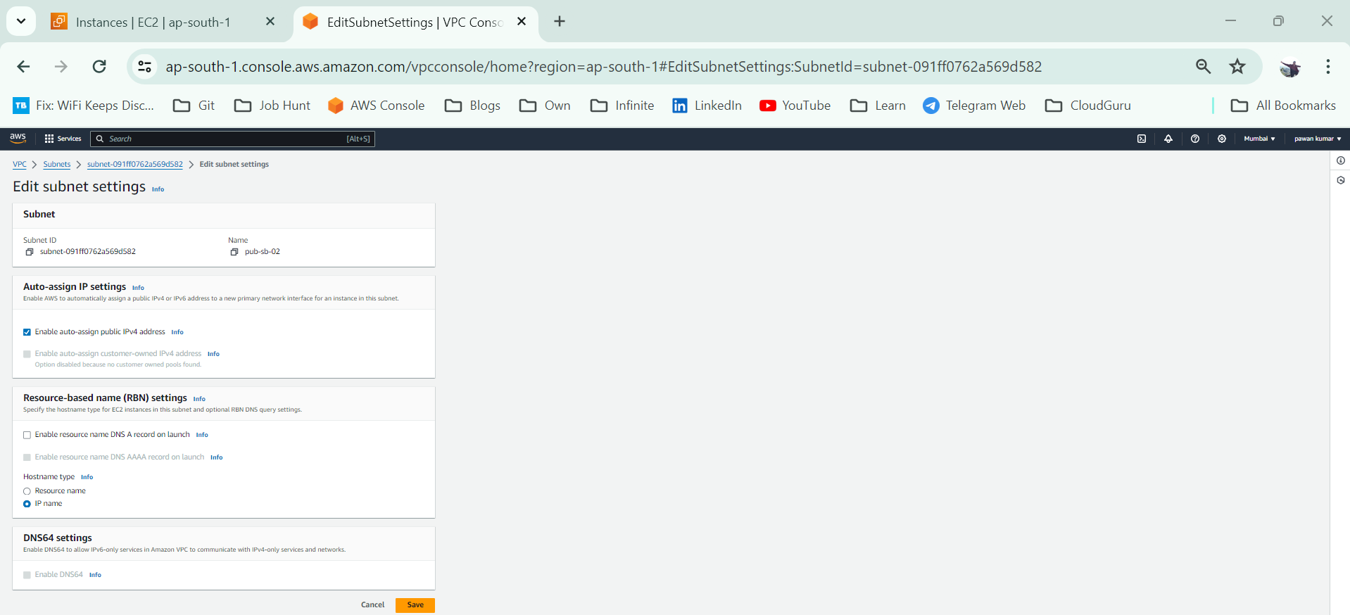

**Navigate to IGW**

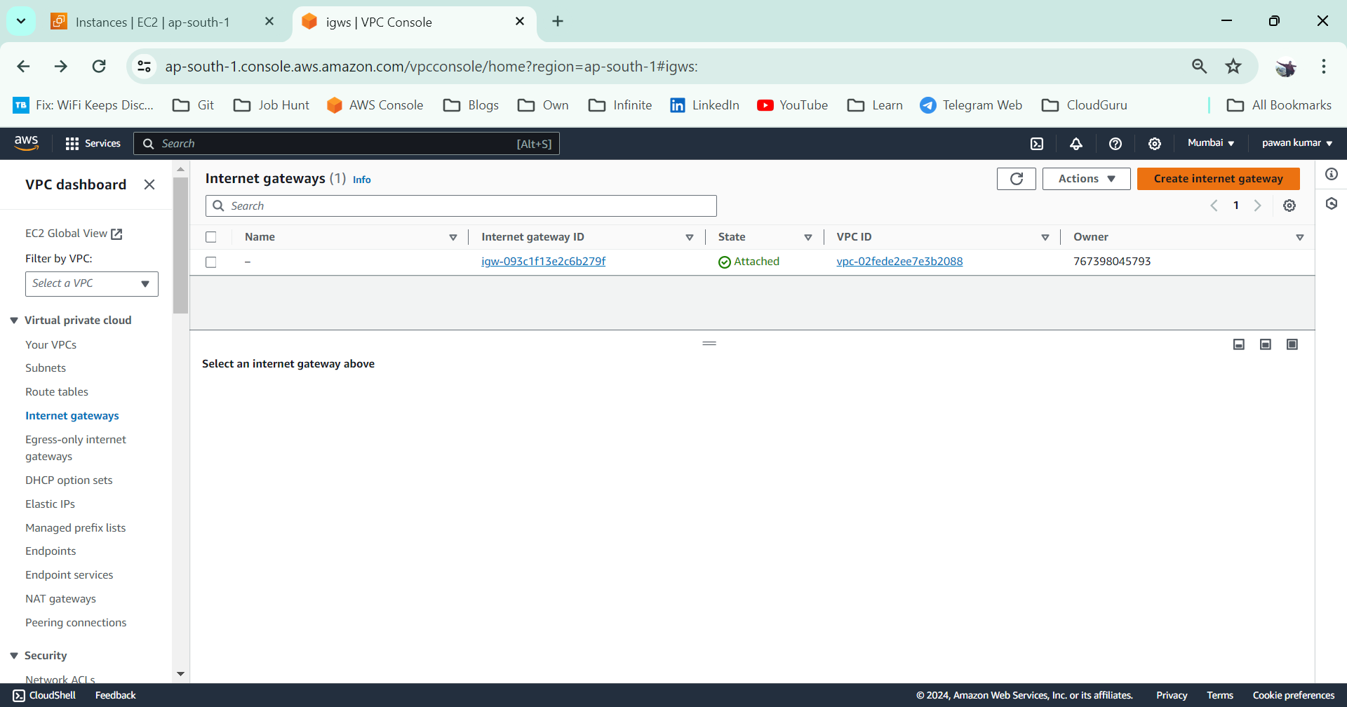

**IGW01**

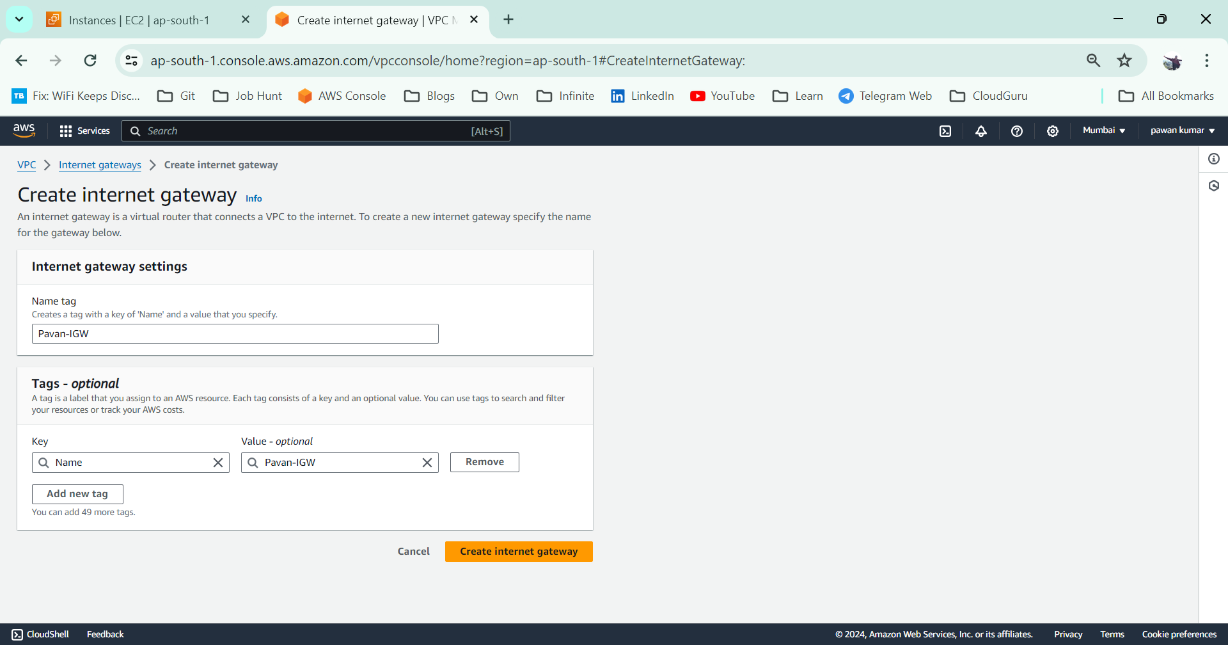

**Select IGW & Actions 🡪 Attach to VPC**

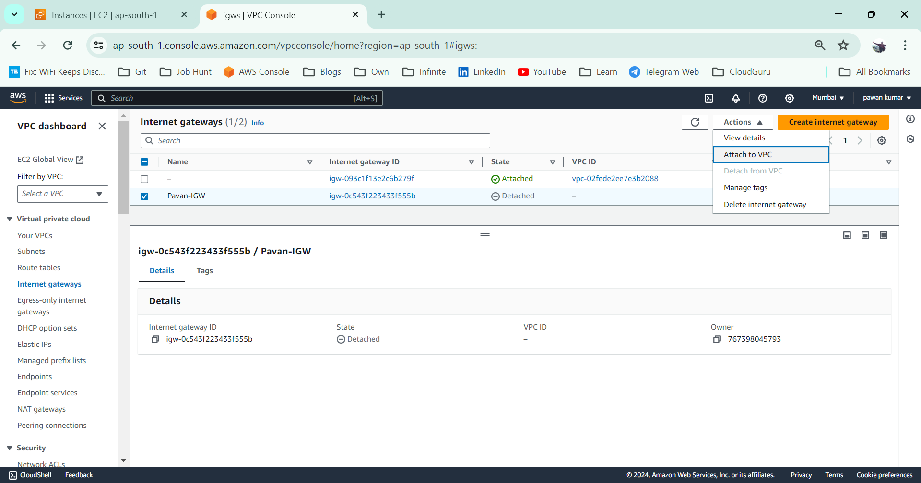

**Choose Custom VPC created & then click on Attach Internet Gateway**

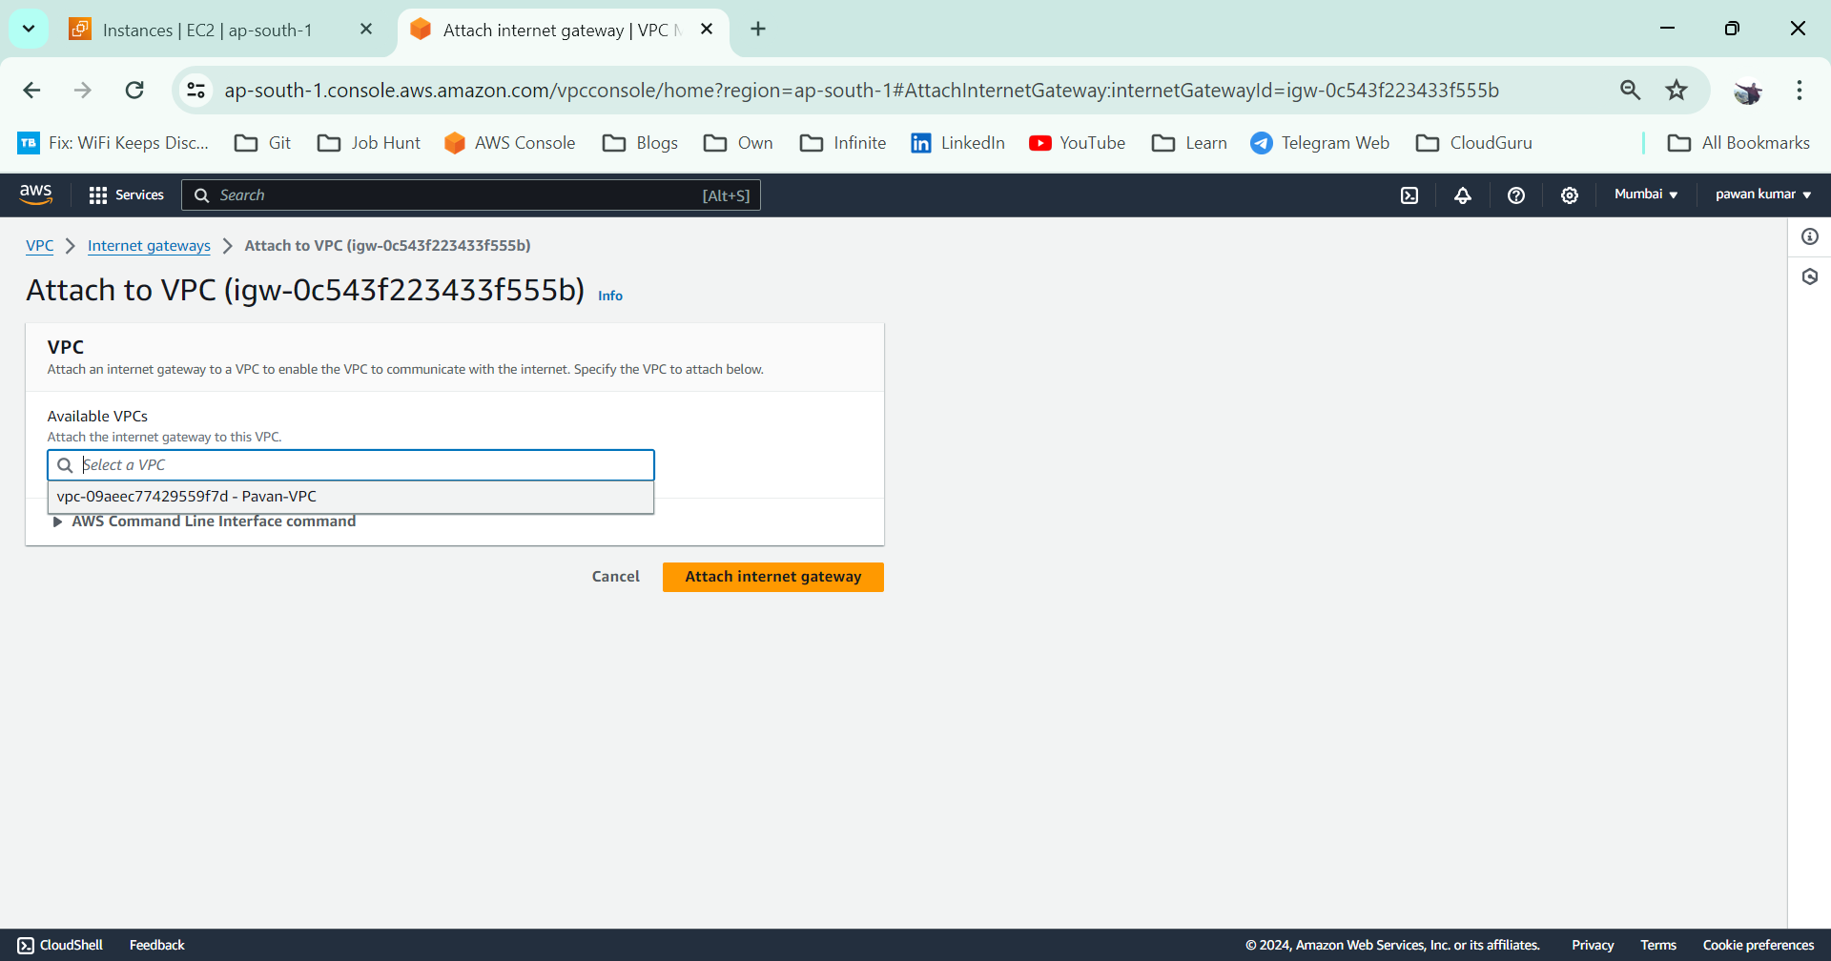

**Navigate to RT**

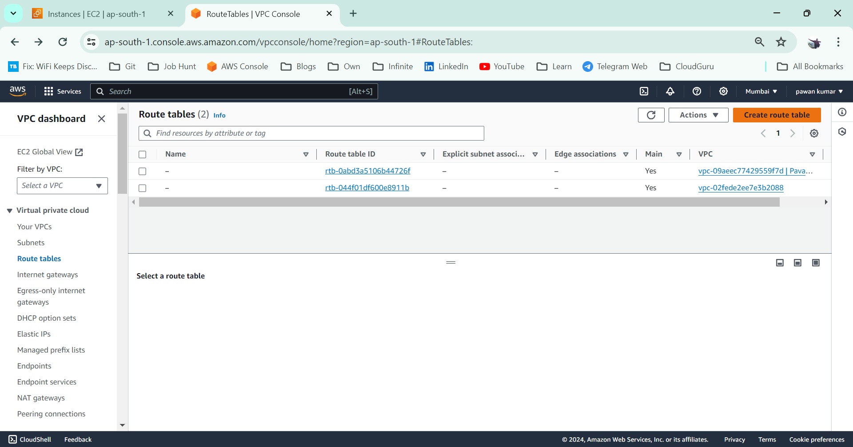

**IGW is created**

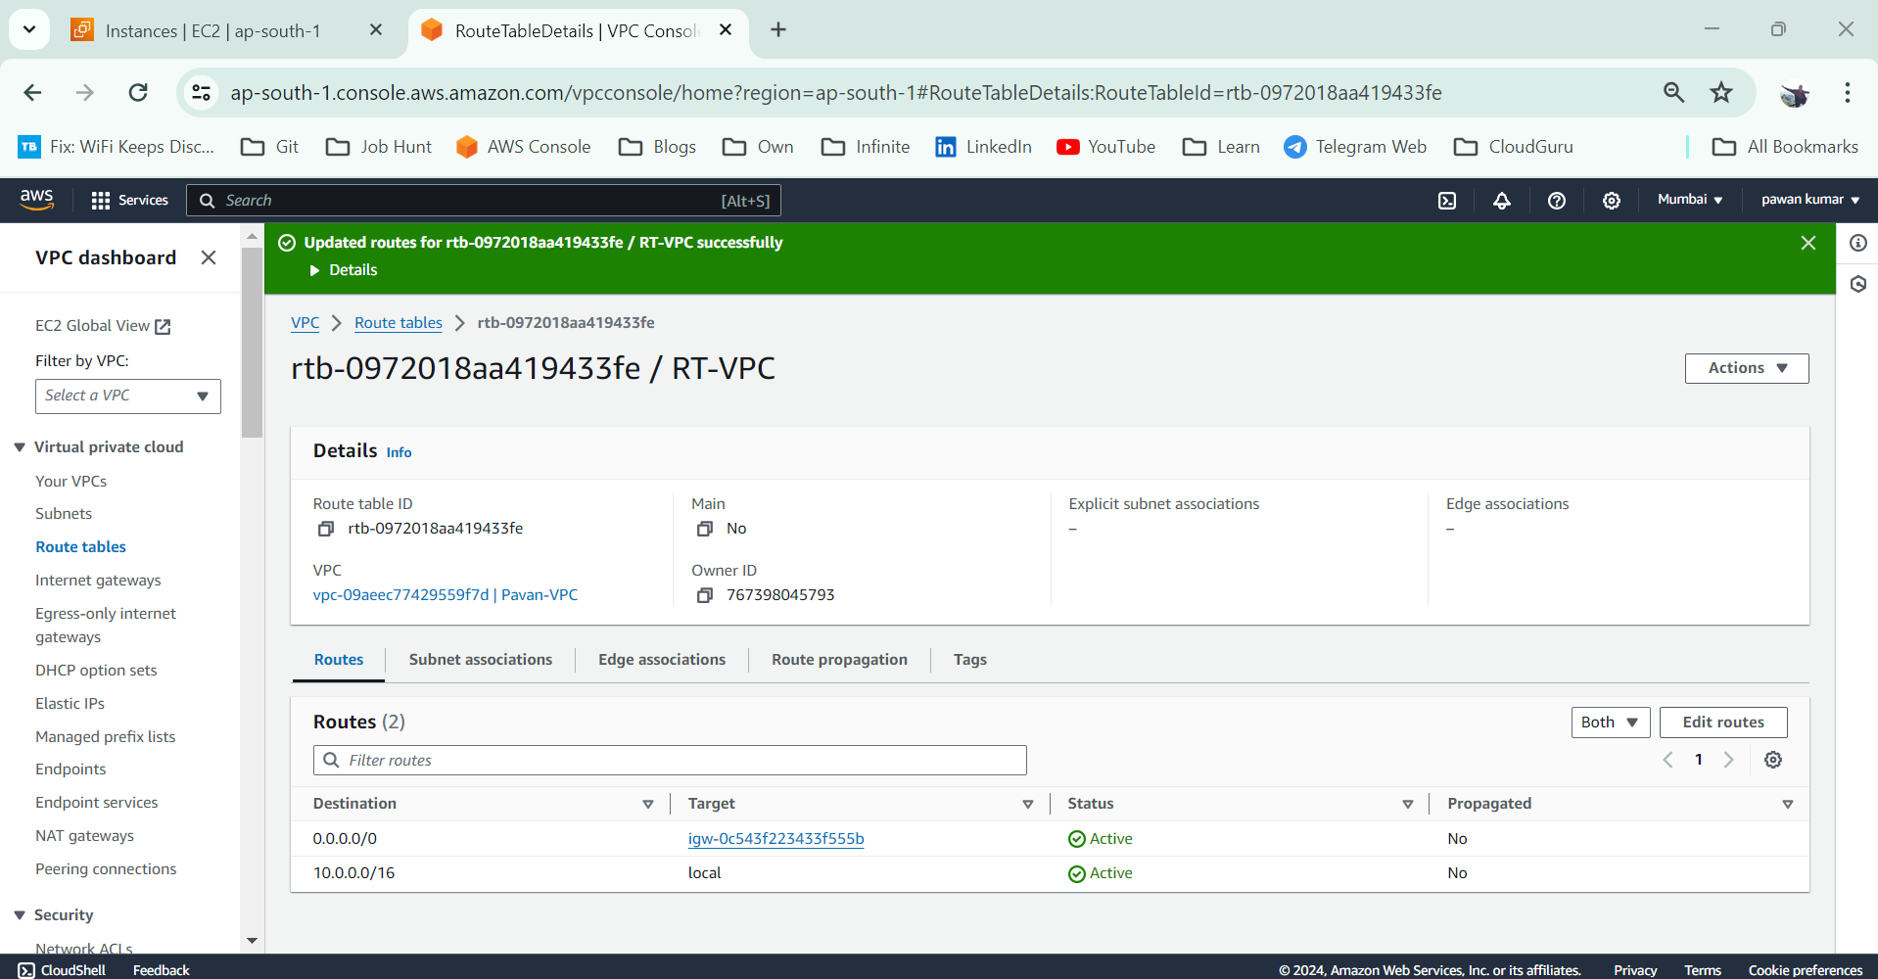

**Navigate to Route Table & then create Route Table**

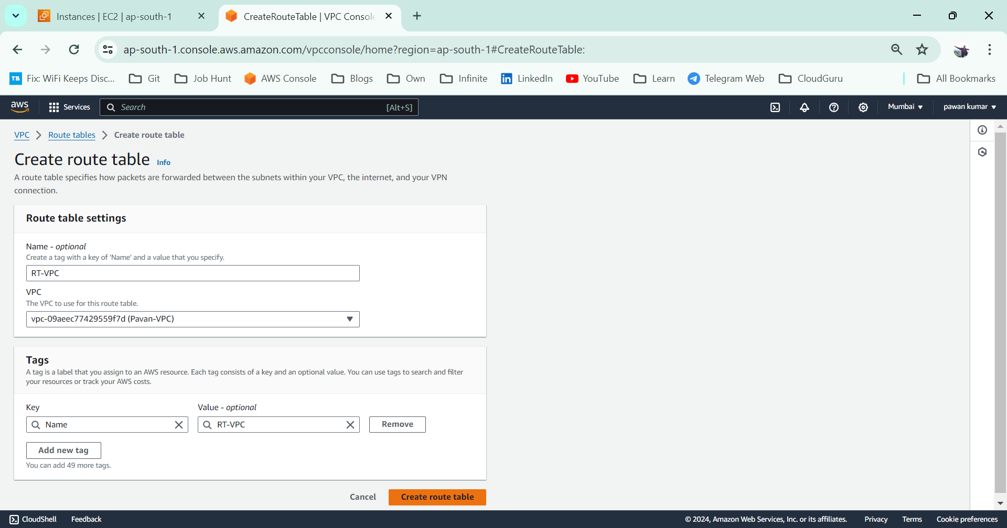

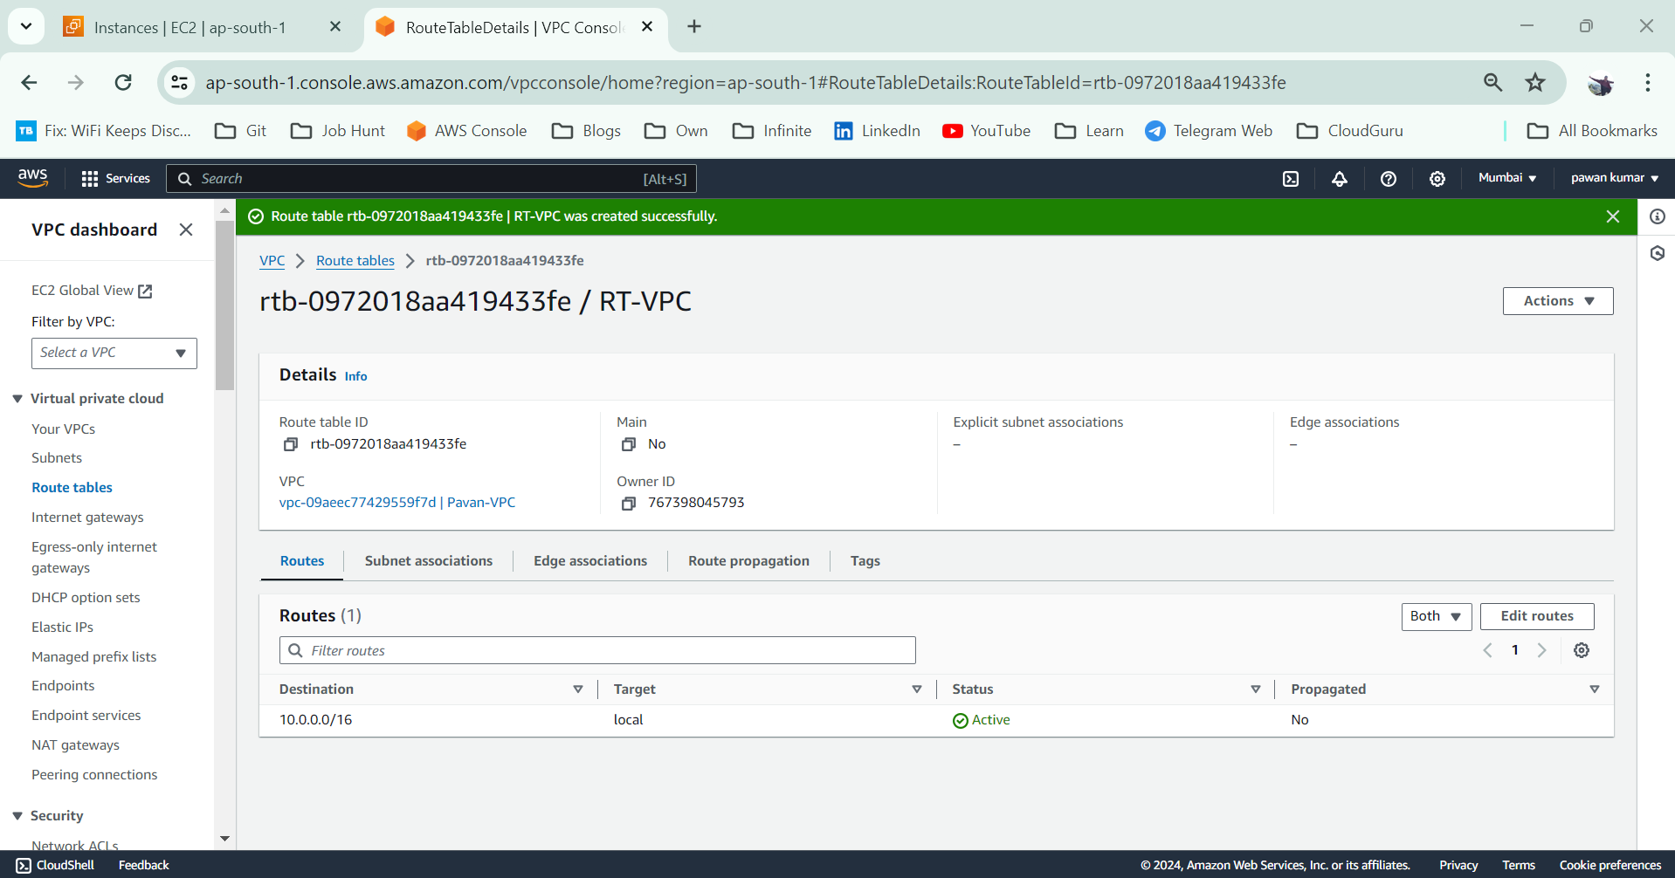

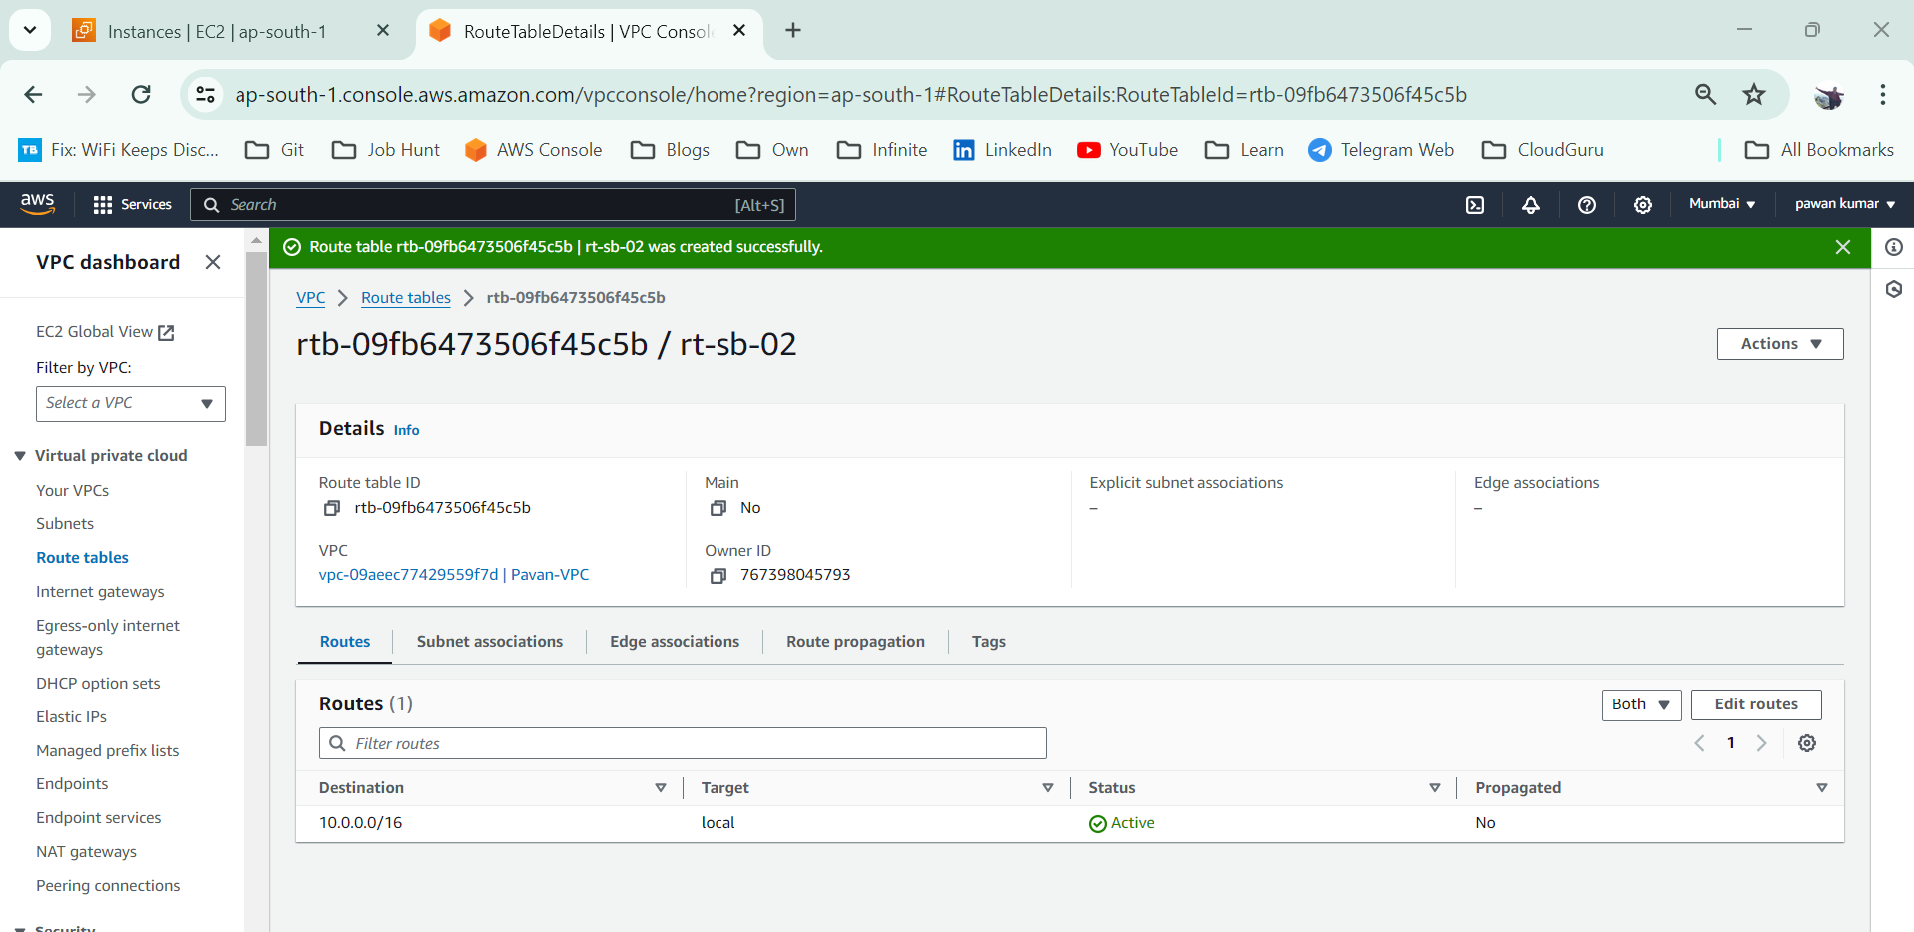

**Actions 🡪 Edit RT**

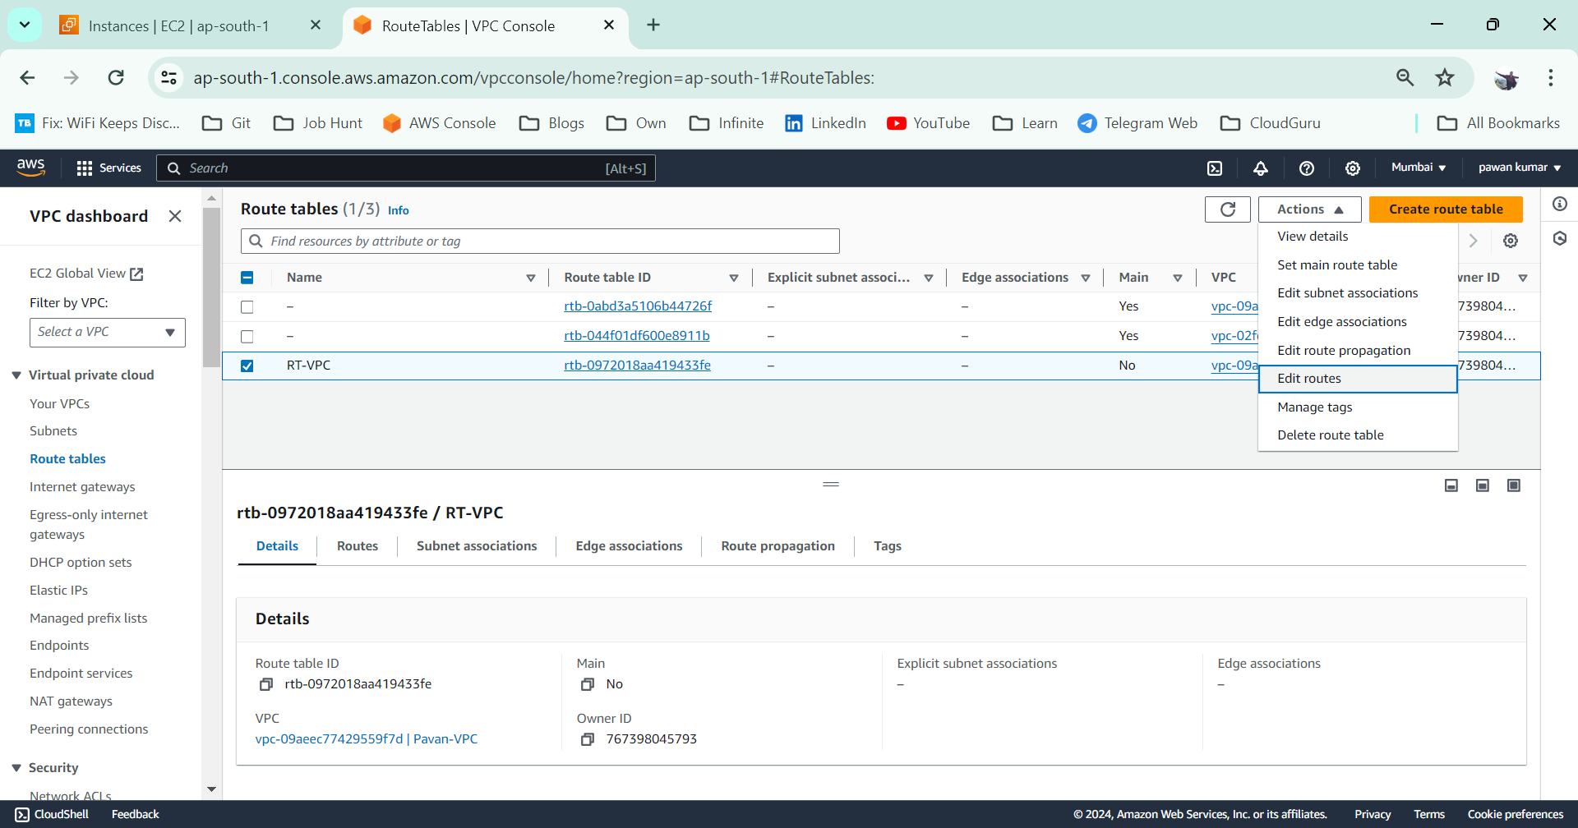

Click on Add New Route

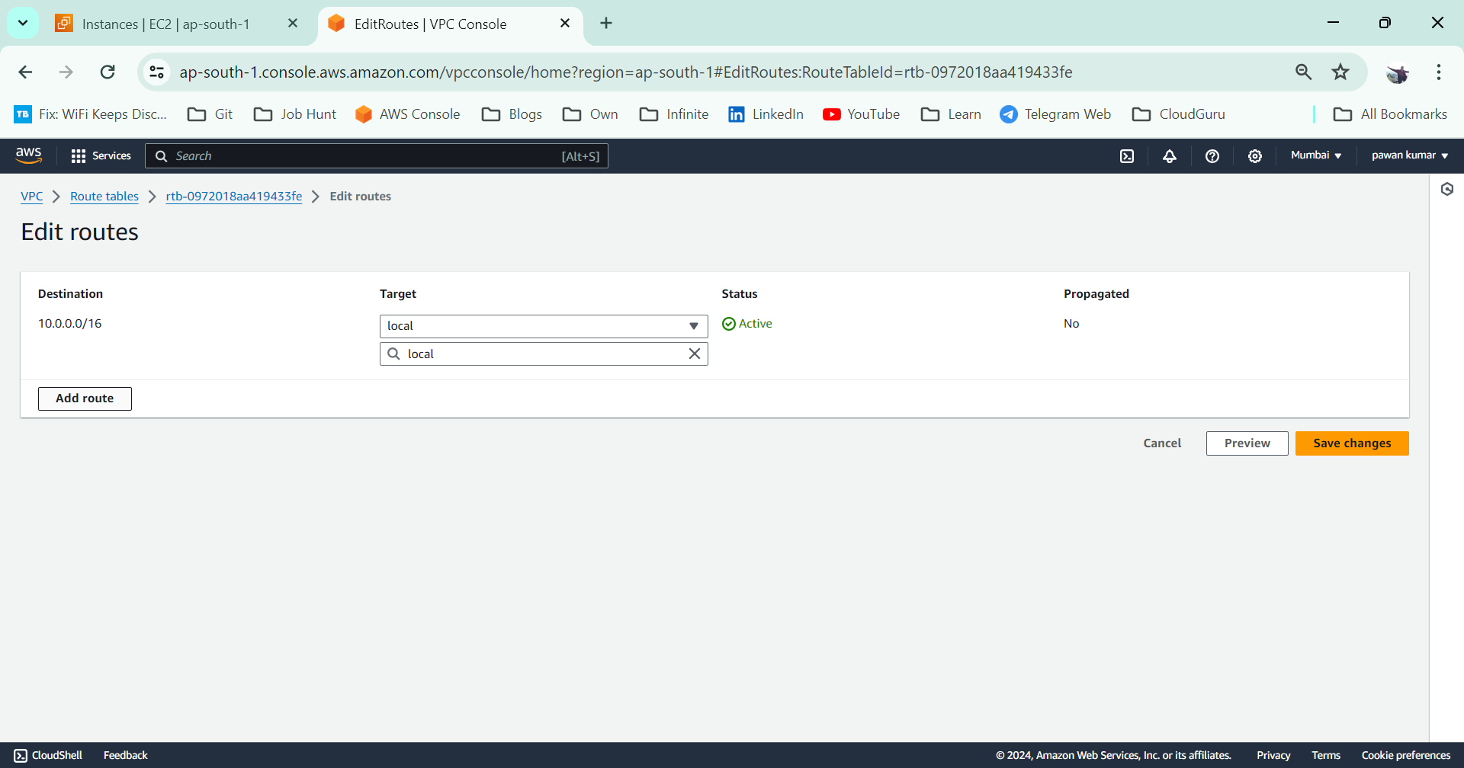

**Then choose 0.0.0.0/0 address & select IGW**

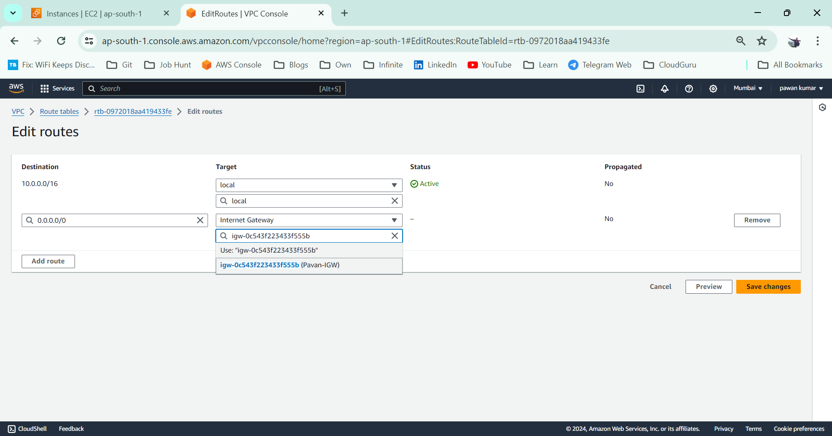

**Select RT & then click on Subnet Associations as shown in figure**

**Note: Choose only Explicit subnet Association otherwise we can’t access the instances**

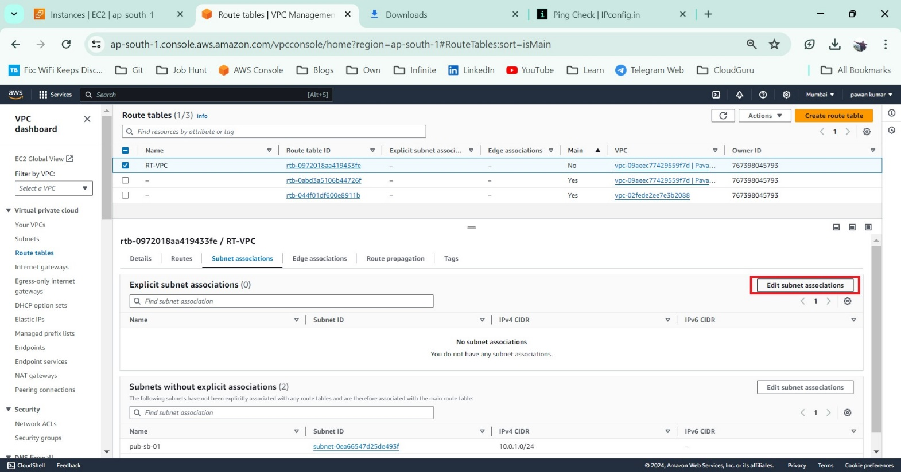

**Select two subnets & then save**

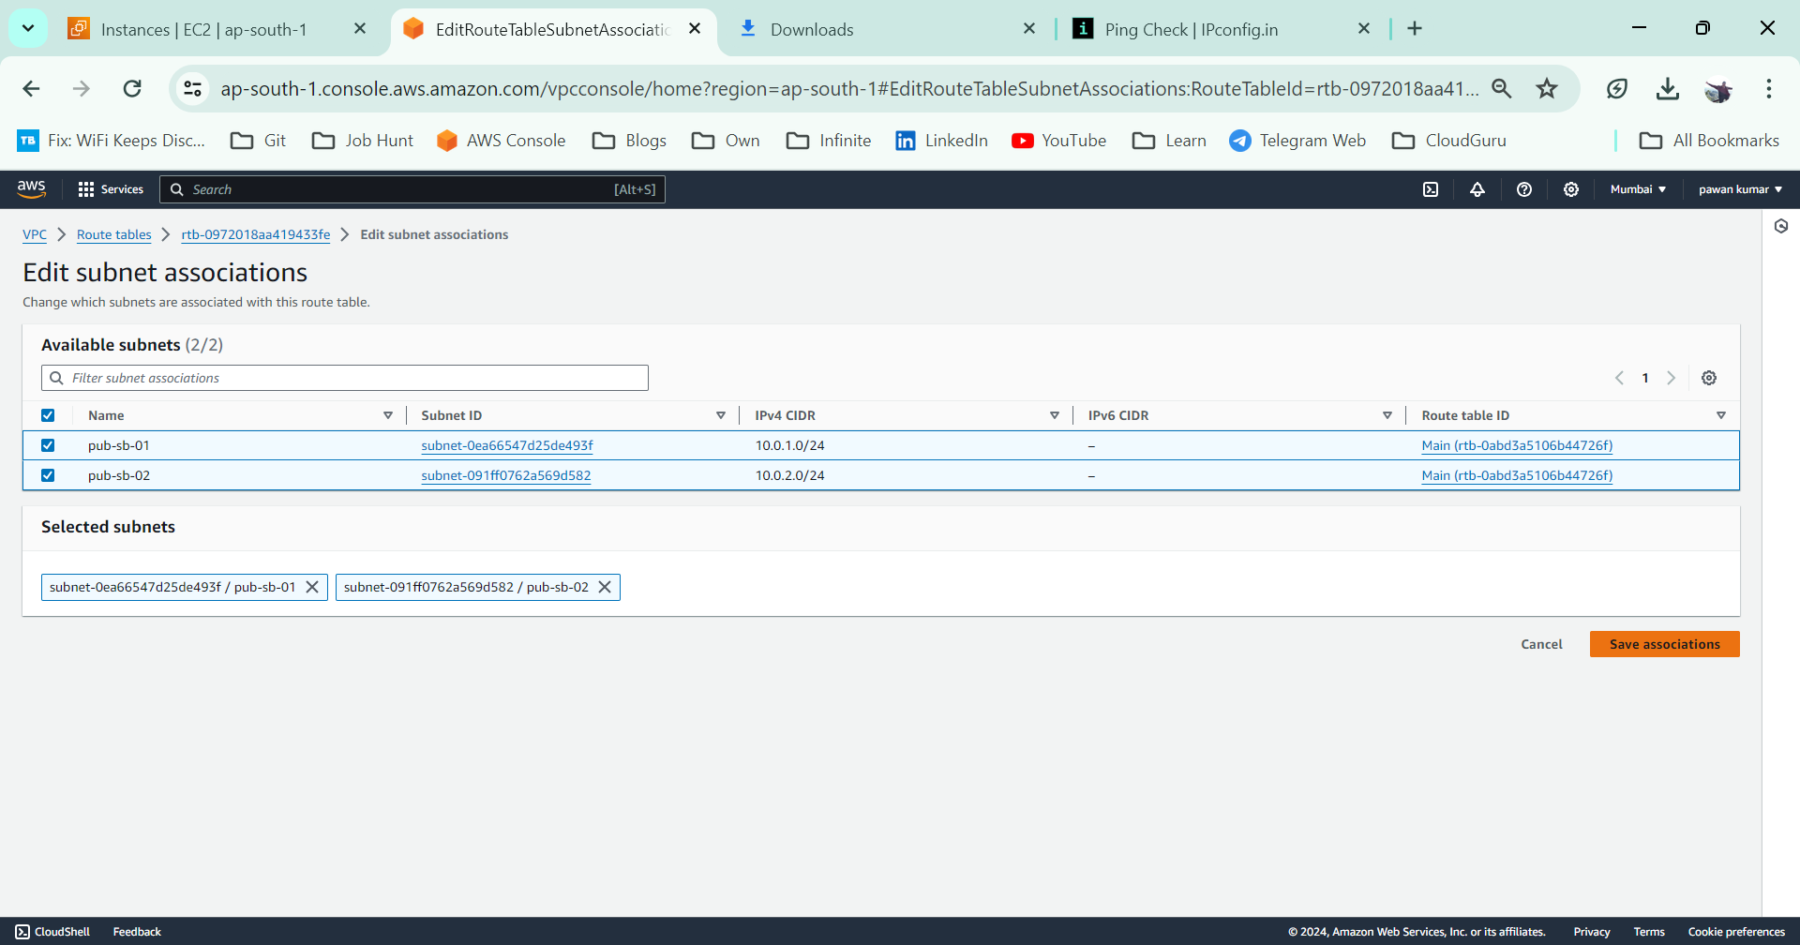

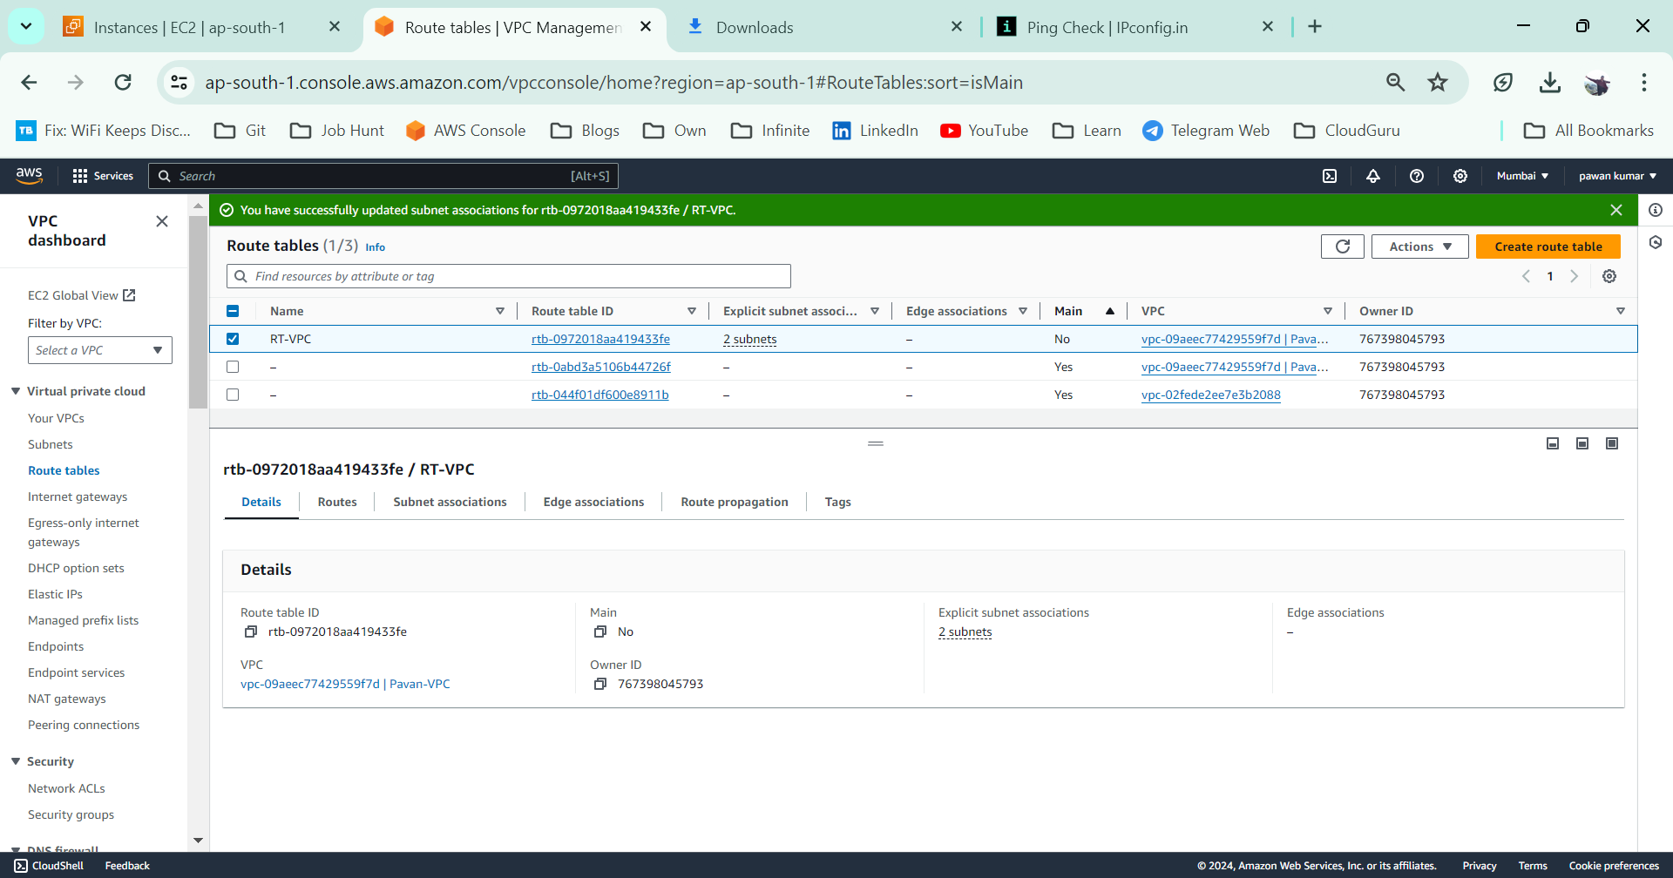

**Launch Instance-01 in subnet-01**

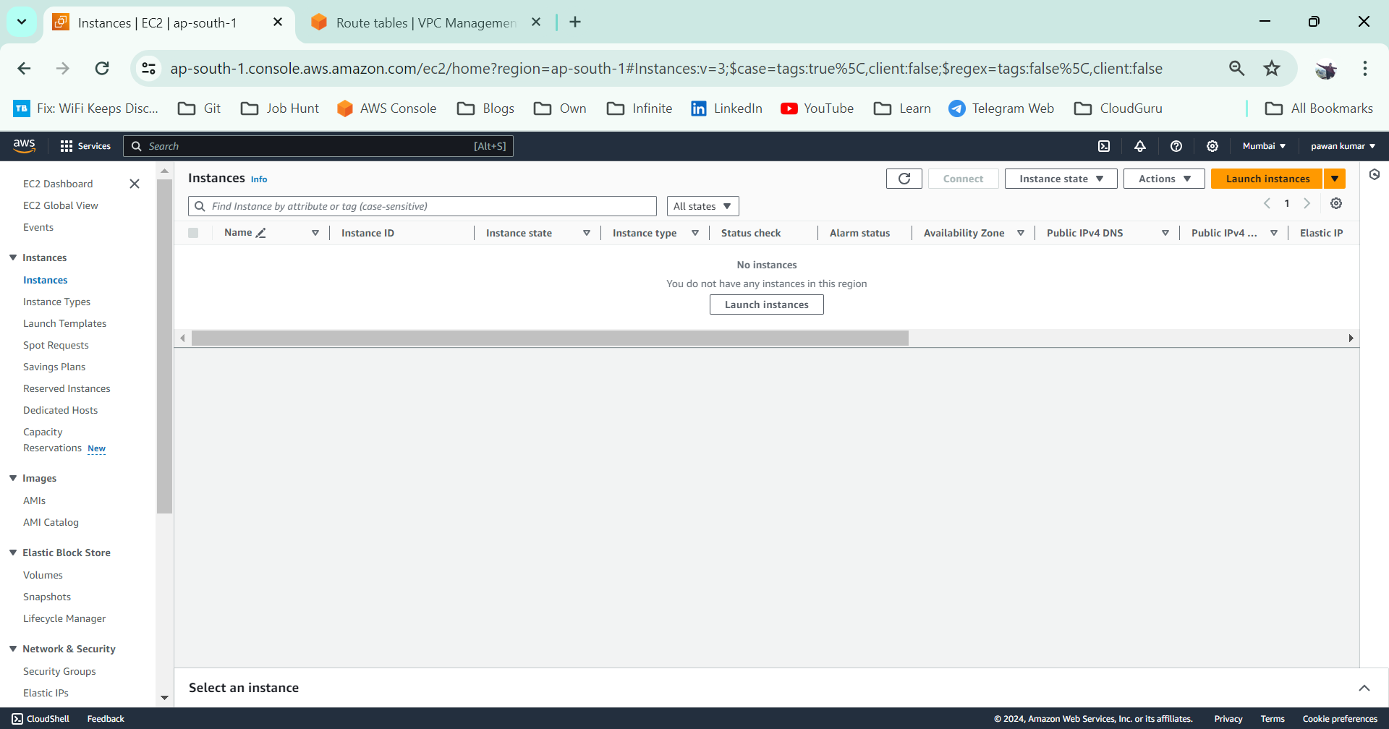

**SG settings🡪**

**SSH(22) for My IP 🡪 IP/32**

**http for anywhere 🡪 80**

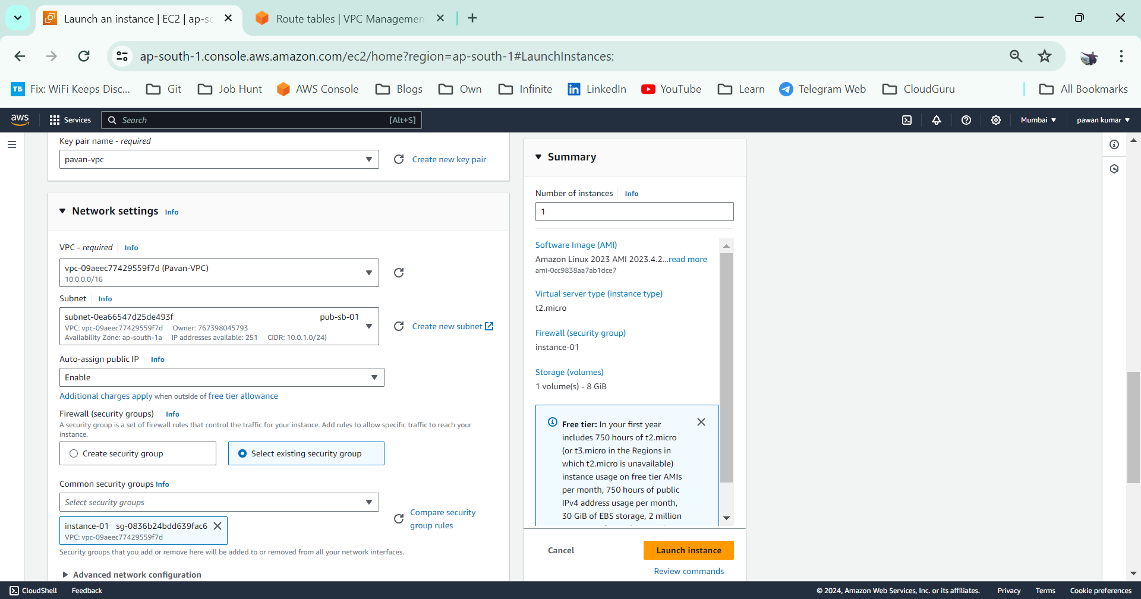

**Instance creation is in progress**

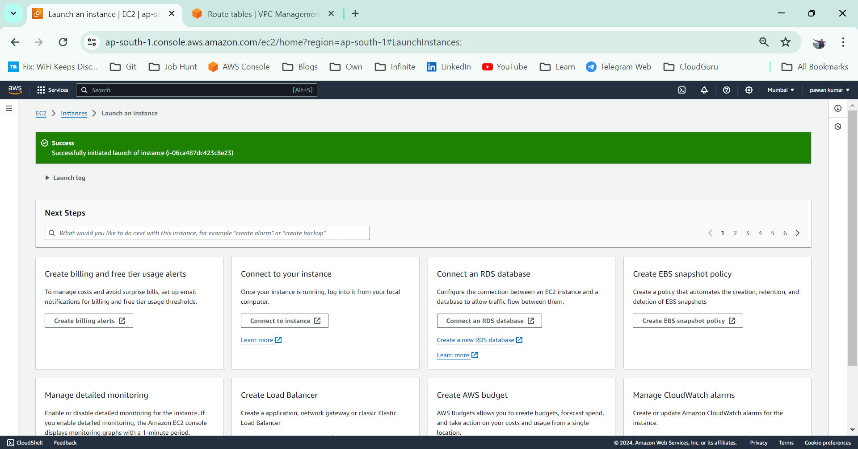

**Launch Instance-02 in subnet-2**

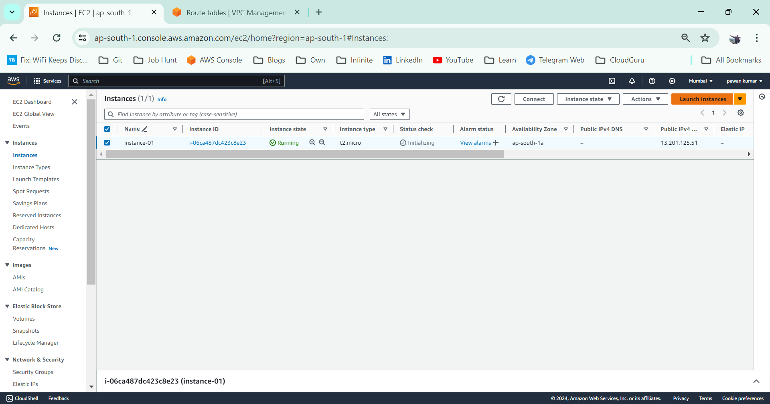

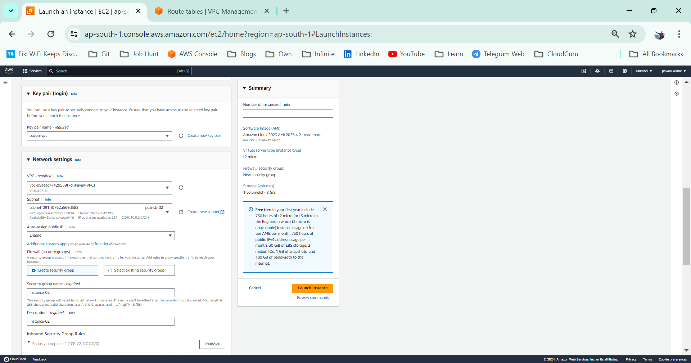

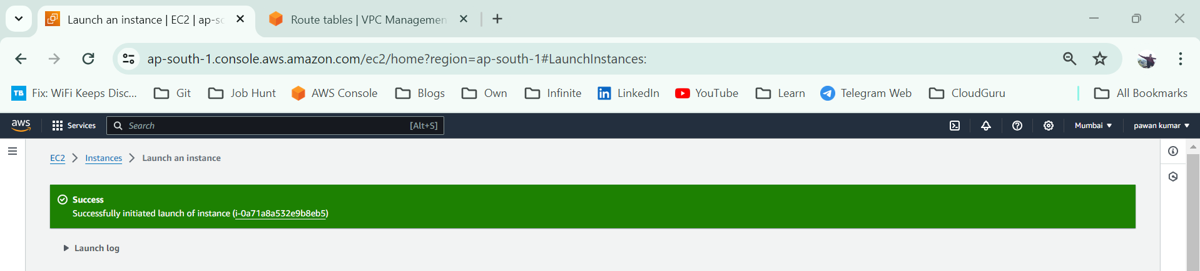

**Communication Check**

**Login into Instance-01**

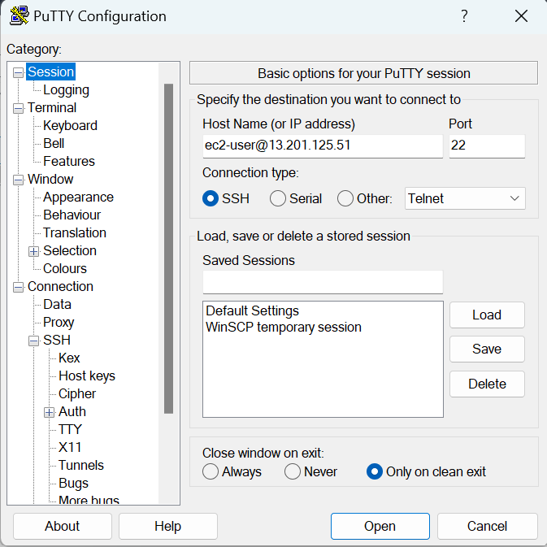

**Ping google**

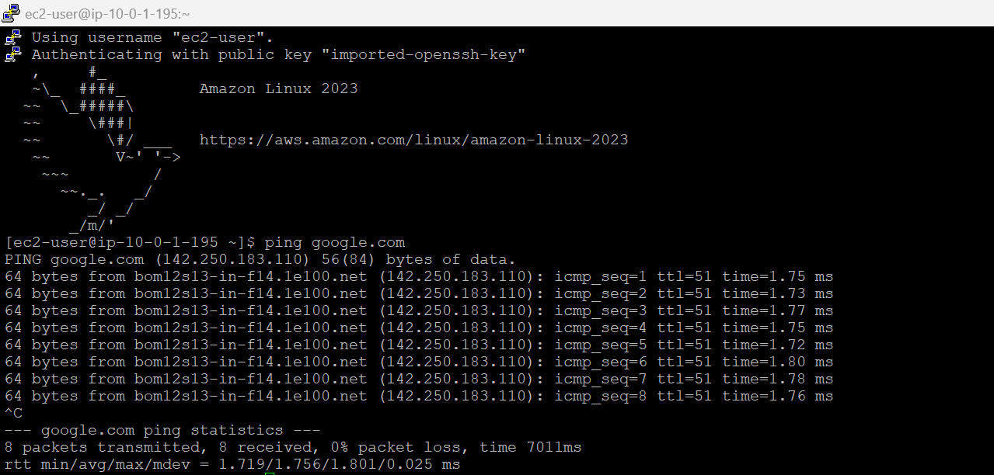

**Login into Instnace-02**

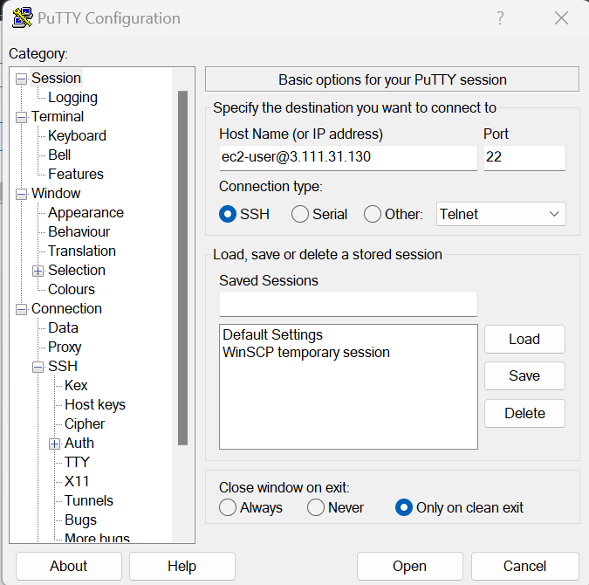

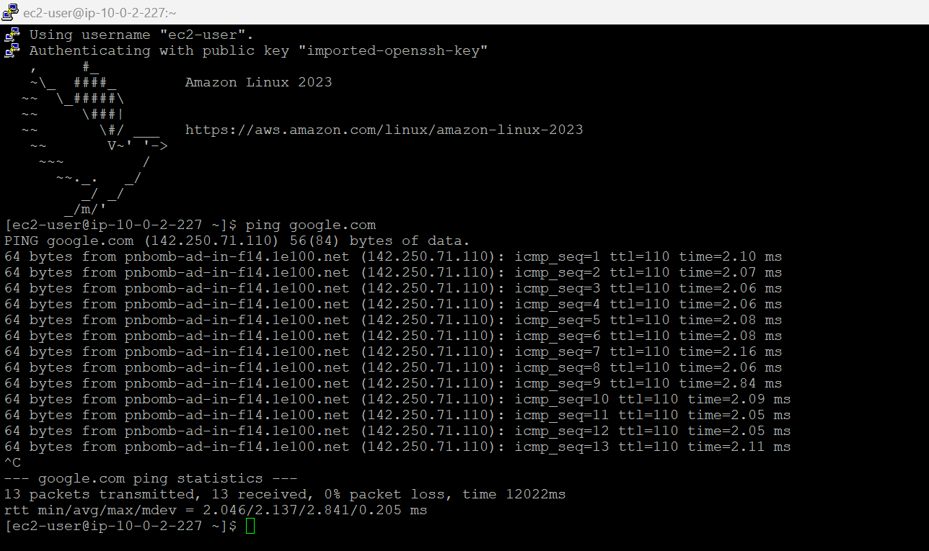

**Unable to get response when pinging b/w instances**

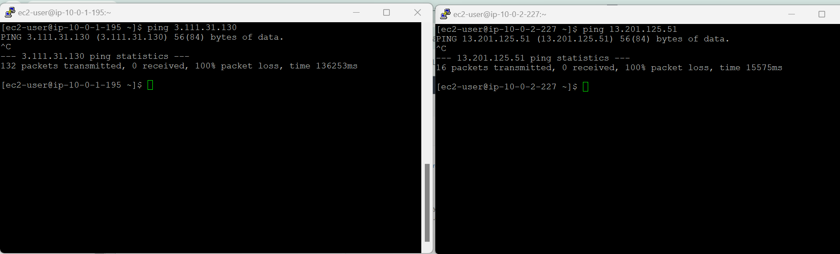

**https://stackoverflow.com/questions/21981796/cannot-ping-aws-ec2-instance**